Umbra

Josh Reeves

University of Missouri – Kansas City

Table of Contents
Vision Statement 3
Requirements 4
Product Backlog 5
Sprint #1 6
Review 6
Retrospective 6
Sprint #2 7
Review 7
Retrospective 7
Sprint #3 8
Review 8
Retrospective 8
Sprint #4 9
Review 9
Retrospective 9
Sprint #5 10
Review 10
Retrospective 10
Sprint #6 11
Review 11
Retrospective 11

Vision Statement

Umbra is a simple 2D game where you pilot a ship through space, somewhat similar to Asteroids. The main objective of the game is survival and resource collection, similar to Snake. Controls will be minimal, focusing on the casual market. There will be aspects to the game for all players, but focus on the casual players. To appeal to collectors and the few dedicated players, there will be collectible ships, upgrades, and rewards for scoring well. To add to challenge there will need to be a few hostile classes. For immediate release, a basic alien type and avoidable asteroids are the initial planned enemies.

In the future, additional gamemodes may be added to give more than simple survival, for example a puzzle game mode with objectives to complete or a multiplayer mode. Also implementing a randomly generated map would be a good addition. Lastly, more enemies with differing AI and abilities.

Requirements

Actor | Goal
Casual Player | Launch into a game session that will last an average between one to five minutes
Collectors | Have collectible items based on score, time spent, etc.
Fan | Create challenges and reward skilled play
Player | Make navigation and controls easy to understand, simplify everything to appeal to a wider audience
Player | Randomize elements to increase replayability and keep players attention longer
Developer | Have a simple engine to create the necessary elements to create the game.

Product Backlog

Story ID | Story | Story Points  (in est. hours) | Priority | Status
1 | Basic art assets are needed to convey information | 2 | 0 | C
2 | Simplistic UI is needed to show game information | 2 | 0 | C
3 | As a developer, I want to set up a simple engine so that I can modify the game | 10 | 0 | C
4 | As a collector, I want to have many options in the game. | 5 | Mid | NS
5 | As a player, I want the difficulty to be fair and balanced | 5 | High | I
6 | As a fan of the game, I want there to be some challenge and rewards to go with that | 10 | Mid | I
7 | The player must have a control scheme to pilot the ship and avoid collisions | .5 | 0 | C
8 | Audio cues add to the experience and help player understand what is happening | 3 | 0 | C
9 | As a player, I want to have some hostile obstacle to overcome in the game | 2 | 0 | C
10 | A basic intro animation would clean up the starting of the game and be good transition from the title | 3 | 0 | C
11 | As a player, I want a consistent UI between screens (title, game, options) | 5 | 0 | C
12 | To keep players invested, the controls need to be tuned to be intuitive and have depth | 4 | 0 | C
13 | As a player, I would like to customize my experience with the game | 10 | Low | NS
14 | As a player, I would like a variety of consistent enemy types | 10 | 0 | C
15 | A basic ending animation would clean up the end of the game and be good transition to the game over menu | 2 | 0 | C

Status Codes:
NS = Not Started
I = Incomplete
C = Complete

Sprint #1

Sprint Plan

The main goal for this sprint is to work on story 3, getting a basic engine up and running. I will need a game loop activity that will house the play session. I need to be able to draw and delete objects, control their movement, decide how and where they will be drawn, have a score counter, and a health manipulation function. Also to go along with this, the UI may be added, which is story 2. This is a total of 12 estimated hours.

Velocity: 10.5

Sprint Backlog
Story ID | Story / Task | Estimated  Hours | Actual  Hours
3 | Create core game loop | 3 | 1
3 | Draw and move assets linearly and rotate around fixed point | 3 | 4.5
3 | Create player movement functions and map movement | 3 | 3
3 | Add game control functions, such as score counter and health manipulation | 1 | 1
2 | Add UI to show health, score, and shield countdown | 2 | NC
7 | Add a control scheme to pilot the ship | .5 | .5

Review

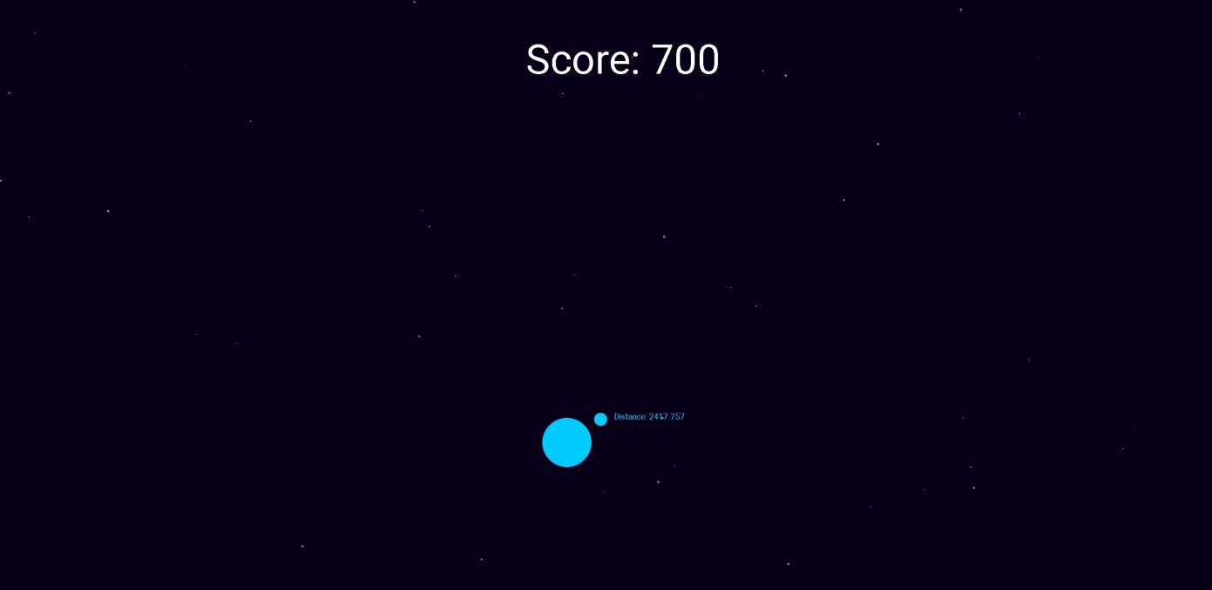

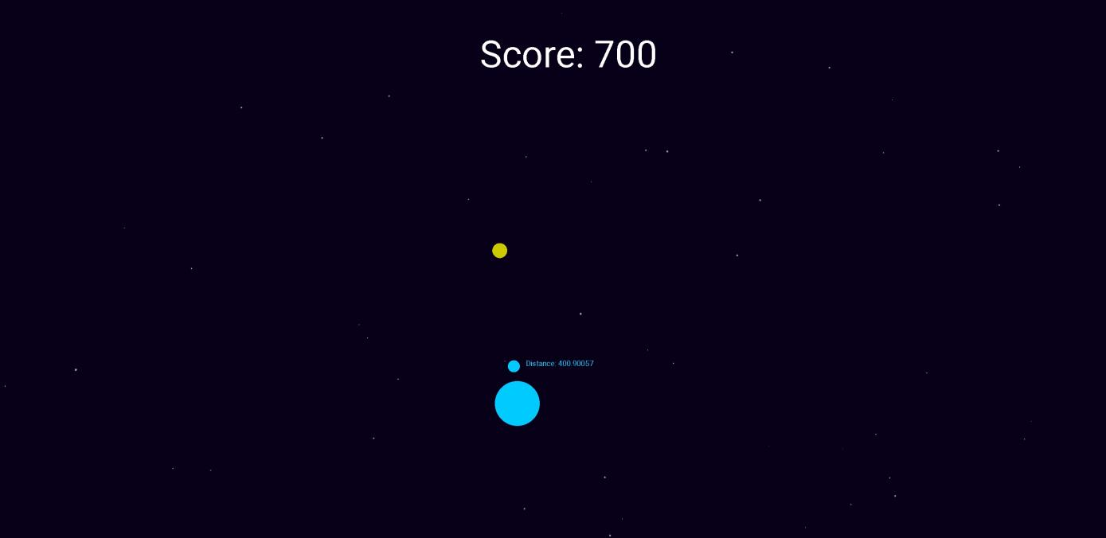

The basic game engine is finished, including the core game loop, player movement, background movement, goal randomization, score manipulation, and can be easily updated to add more functionality depending on what will be added to the backlog in future iterations. I planned to also work on the UI to give more information, but only implemented the score. Currently, the game is simply moving and rotating towards the goal point to increase score.

Retrospective
Firstly, I will need to focus more on the test driven side of the project. I wasn’t sure how to write unit tests for a lot of the work I knew needed to be done first. Also some of the methods require complex maths to work out, such as player movement and testing this for exact values is quite difficult.
Second, I need to find a way to prioritize the next thing to do in a more efficient way. My main struggle with this first sprint was having no idea where to start in building the game engine. After a few days of making the functionality but failing in a good solution for drawing at a framerate, I searched for a simple engine and used the structure. After that, things went much faster.

Sprint #2
Sprint Plan

The main goal for this sprint is to improve on the engine and add features to make the game more fun. I will focus on adding a hostile class into the game as well as some progression. For engine improvements, I want to have an intro period where the game starts, include audio, and add the elements I didn’t get to in Sprint 1 to the UI. This is a total of 9 estimated hours.

Sprint Backlog
Story ID | Story / Task | Estimated  Hours | Actual  Hours
2 | Add UI to show health, score, and shield countdown | 2 | 4
1 | Create basic art assets | 2 | 3
10 | Add introduction animation | 3 | 2
9 | Add hostile enemy type | 2 | 3

Review
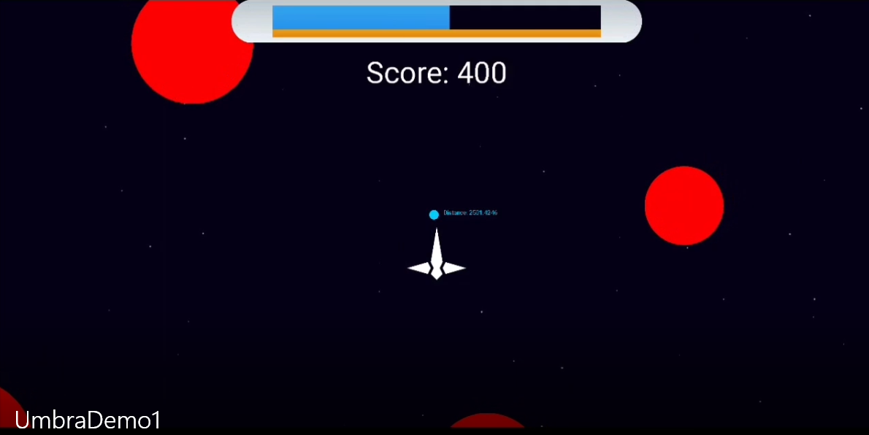
Since images don’t do much justice to show a game, I have a video demo Included in the Github repository or at https://youtu.be/qFXIkTQvKVo.

Adding the hostiles was one of my first tasks in order to add some difficulty to the game. It was a bit more challenging than I anticipated to set a difficulty curve and decide how to place and evaluate behavior of the hostiles as they moved linearly, as opposed to the static points I had been working with previously. Currently there is a beginning amount of hostiles that will be set as the game starts, and it will progressively increase until reaching a maximum value.

I also added art assets for the player and the UI. Getting the UI to display properly (health bar and action bar scaling) took much longer than expected. I had to create and test several versions before settling with the one I preferred. I will likely come back and redesign some of this.

Lastly I added an introduction animation showing the goal and the player’s ship flying in right before the game starts. This took less time than expected, and I will want to repeat the methods for an ending animation after the game ends.

Retrospective
This time around, my time management was very poor. I will need to focus more time upfront and less cramming in the final week. Completing the tasks went fairly well other than miscalculating how long each item would take. I will do more planning early on next sprint and work on things ahead of time.

Sprint #3
The main goal for this sprint is to make the game feel like a complete package. The main game loop is all I have focused on so far, and I need to give the other elements attention, such as the title screen and audio. Also in play-testing my game with some coworkers and friends, I found that the controls weren’t very intuitive until explained. I will need to address this early on (most likely with UI improvement). This is an estimated total of 14 hours.
Sprint Backlog
Story ID | Story / Task | Estimated  Hours | Actual  Hours
8 | Add Audio Manager to engine | 2 | 2
8 | Create or find royalty free music and sound effects | 2 | 1
11 | Add Title Screen | 2 | 1
11 | Add Options Screen | 1 | 1
11 | Add Game Over Screen | 2 | n/c
12 | Update control scheme to be more user friendly | 1 | 1
12 | Add an action button that will add functionality | 3 | n/c

Review

For functional improvements, this sprint I added a title screen and options menu, as well as an audio manager that handles a looping background music and can play sound effects. Also I added indicators to give a hint towards the control scheme. I didn’t get to implement all I wanted to, however, as I spent a lot of time in bug fixing and refactoring. I will definitely need to come back to a lot of the work I started in this sprint and update it, changing the appearance or modifying it based on user feedback.

Video link: https://youtu.be/4C0GZIsN1l4

Retrospective
For this sprint I spent a lot of time refactoring my code. I had basically one class doing all the work, so I split it up into many objects. It could still use a bit of work, but it is much easier to work through solutions now that the code is more modular. My code previously had a high coupling between all systems and I am currently trying to remove as much of that as I can. Next sprint I should have an easier system to maintain and should be able to get more done as a result.

Sprint #4
The primary goal for this sprint is to finish the items I didn’t complete in Sprint 3, then move towards changing the game enemy structure. Currently most of the design is randomly generated and loops infinitely, but with user feedback I may move to a faster paced and more structured design.

Sprint Backlog
Story ID | Story / Task | Estimated  Hours | Actual  Hours
11 | Add Game Over Screen | 2 | 2.5
12 | Add an action button that will add functionality | 3 | 2
11 | Add better functionality to Options Screen | 2 | 2
11 | Add Pause menu | 1 | 1
14 | Design first new hostile | 4 | n/c
14 | Design second new hostile type | 4 | n/c
14 | Play-test to find appropriate variables for difficulty | 2 | n/c

Review

First, I focused on completing what I hadn’t done in the previous sprint. There was a bit more refactoring to finish and a few screens to implement so the game has a definitive start and end point, and can be paused at any time. I wanted these done so the game is more of a finished product, rather than a decent game loop but no menus surrounding it.

Secondly, I added a firing button where the player can launch a laser in front of them. It will be used to eliminate hostiles when they become more complex. I didn’t get around to finish implementing and testing the new hostiles, but they are designed and their formulas are all written out. I will need to test placement and amounts to see how their difficulty scales as well as app performance.

Video link: https://www.youtube.com/watch?v=3jt7lP7g5Vk

Note: My screen recording software can no longer capture audio from the app. The volume settings do work, but I couldn’t show that in the video. Audio coming from the video is through my headphones, so the quality is very poor.

Retrospective
The process is going quite smoothly now that I am more used to it. The biggest issues I run into are creating, prioritizing, and estimating stories. Implementing the features is methodical and pretty straightforward. This sprint I spent a lot of time on trying to fix the small bugs and finish the refactoring process. I didn’t get to testing and finishing the new hostile types, so I will have to add them to the next sprint.

Sprint #5

My goal for this sprint is to finish the new enemy classes and fundamentally change the feel of the game. It will have more structure to the projectiles now, coming from an enemy source. This will likely prompt several other changes to earlier systems that I can’t fully predict. Also to give the player more information and feedback, I will create and add sound cues for any important game events.

Sprint Backlog
Story ID | Story / Task | Estimated  Hours | Actual  Hours
14 | Create Hostile Base Class | 2 | 2
14 | Implement two hostiles derived from base class | 4 | 7
14 | Play-test to find appropriate variables for difficulty | 2 | 1
8 | Create sound effects for hostile destroyed, goal collected, player taking damage, etc. | 2 | 1
8 | Add sounds effects to game | 1 | .5

Review

This sprint, I finished the enemy classes I had planned to create for last sprint. I vastly underestimated the time it would take to work out a lot of the issues I had with them, specifically placing the projectiles in the correct location and rotating them. The placement still seems slightly off for some reason, I believe it may be due to rounding errors when converting to an integer for placement.

Also, I tuned the settings for damage and speed to make the game less difficult since the new enemy types made it significantly harder to avoid projectiles. Lastly, I also added sound effects for all major parts of the game, firing, being hit, collecting a goal, and the game end when I add an animation later on.

Video Link: https://www.youtube.com/watch?v=iFnwss5XTPE

Retrospective
I spent a lot of time this sprint trying to fix errors when adding functionality to the enemy types. One large bug that took a significant amount of time for me to notice was the y axis on android is reverse to what I expected. This didn’t matter when my projectiles were moving in random angles, but when I had fixed angles they needed to travel, I needed some way to track that sooner. I should have tested for movement patterns given an angle much earlier in development. Other than the issues with that class, the process went well.

Sprint #6

My goal for this sprint is to add all the items that would complete the main package of the game. Firstly, an ending animation is necessary to close the game loop before the game over screen. Second, I need to track scoring in some meaningful way. Third, I have at least one other hostile type I want to include in the game before I tune the difficulty, amount of hostiles, rate of each type of hostiles, etc. Lastly, I want to move all projectiles out of the enemy class so they aren’t destroyed with the enemy. This is a bit of a stretch goal since it’s the final sprint of the semester, but it’s a feature I would like to change.
Sprint Backlog
Story ID | Story / Task | Estimated  Hours | Actual  Hours
15 | Add Basic Ending Animation | 2 | 1
6 | Track High Scores on Triumphs page | 1 | 1.5
5 | Add final enemy type | 2 | 3
5 | Adjust spawn rates, amount of hostiles, etc | 2 | 1

Review

This sprint, I added another enemy type to try and include some of the randomness of the original idea, since I changed the enemy style in sprint 4 and 5. After this I tested a bit to find what speeds, damage numbers, and collision testing I should use based on feeling of fairness.

I also added a high score tracker that keeps track of the top 10 highest scores, and initializes to multiples of 1000. This would be likely changed later on to add challenges or something else to give it depth.

Lastly I added a simple fadeout animation when the game ends as a transition to the end screen.

Video link: https://www.youtube.com/watch?v=yVq9C9gBfvg

Retrospective
I wish I had more time to work on this as it was the final sprint, but as classes come to an end I needed to spend more time on other projects as well. I didn’t take on as much this sprint and probably could have got more done, but I’m still fairly happy with how it has turned out so far. In this last sprint, I actually could take advantage of reusing some of the code previously written, such as writing the high score methods based on the settings methods and just changing them a bit. I definitely will need to work on designing my code early on for reuse, as in the beginning of this project I had no idea what scope I would end up trying to accomplish, and the result suffered for this.

